Glossary:
-40d20: Rolling a d20, or 20 sided die, 40 times.
-PCs: player characters.
-homebrew: things that are fan-made for D&D, rather than official creations by Wizards of the Coast or TSR (original creators of D&D)
-Monster Manual: a book for D&D that provides statistics and background for various enemy types.
-Saving throw: a d20 roll, modified by a specific ability score, which can allow a creature to resist or end a negative effect on themselves.
Background to the Problem:
Joe is a Game Master at Distinct Gaming, a game shop in Belper. He often runs large-scale combat encounters involving his players’ characters and lots of other creatures, but he is often unsatisfied with the result as he has to make approximations in order to manually work out what is most likely to happen. Joe has requested the creation of a ground-up game in VB which simulates battles between creatures, any of which the user can choose to control. The purpose of the game is for the creatures to be fully customisable, so that each effect applied and each attribute can be changed. This will allow Joe and game masters like him to accurately simulate large-scale battles in a fully customisable environment.
As Joe sometimes finds that he has made a mistake in setting up his battles, he has also requested that he can add scenarios to select from so that he can revisit battles, edit them and run them again.

Interview with the end user:
Q: What’s your existing system for simulating large-scale battles?
JM: There are a few tools online for that with various problems, like using real-time mechanics or just not being customisable enough. Another approach is manually running it with statistical simplifications. For example, instead of rolling 40d20 with a 3/20 chance of success, you just say there have been 6 successes. This still involves calculating probabilities though, and it only works for large groups with the same statistics. Often in my battles there are lots of unique types of creature with their own statistics, so that often isn’t very effective. Also, I have to decide which creatures are hit (if it’s an attack roll), which is not ideal. There is another alternative though, which is to make up the whole fight and guess at the result, but that’s not appropriate when player characters are involved. It also doesn’t give accurate or interesting results most of the time, and a lot of the fun aspects of these fights

Q: What type of battle would you like this program to be focussed towards?
JM: It would be most helpful when the battlefield is big, with lots of combatants, but it would still be more practical than normal D&D if there was lots of detail involved in each creature, like if every monster had its own unique magic sword. In those cases, there are lots of adjustments and effects that I wouldn’t be able to remember. It would also be useful to be able to fully automate a battle so that I can run the battles multiple times quickly, particularly if there are no PCs involved. It would also be best if it was aimed towards the more common tiers of character levels, ie: levels 1-10.

Q: What are the key aspects of 5th Edition D&D that you want to be faithfully recreated?
JM: The combat rules regarding adjustments from magical weapons, shields and armour, magical item effects like the extra damage from the Flametongue, and elemental resistances and immunities, and the “to-hit” adjustments and speed from the creature itself. Also, the option of any creature being automated is a must-have. It would also be nice to have support for special abilities of creatures, like the Medusa’s petrifying abilities.

Q: What is not important that’s in the D&D system?
JM: Picking up or passing around items during combat, house rules, extra damage from critical hits and miscellaneous effects of spells, like the paralysis from Hold Person, are not essential, although they would be nice to have in cases where spell-casting monsters are involved. It also needs to be able to tell what side of the fight each creature is on. I also want to be able to add and select scenarios from a list, and to be able to define and add new creatures and items.

Q: Could you give some example of creatures and items you might want to add?
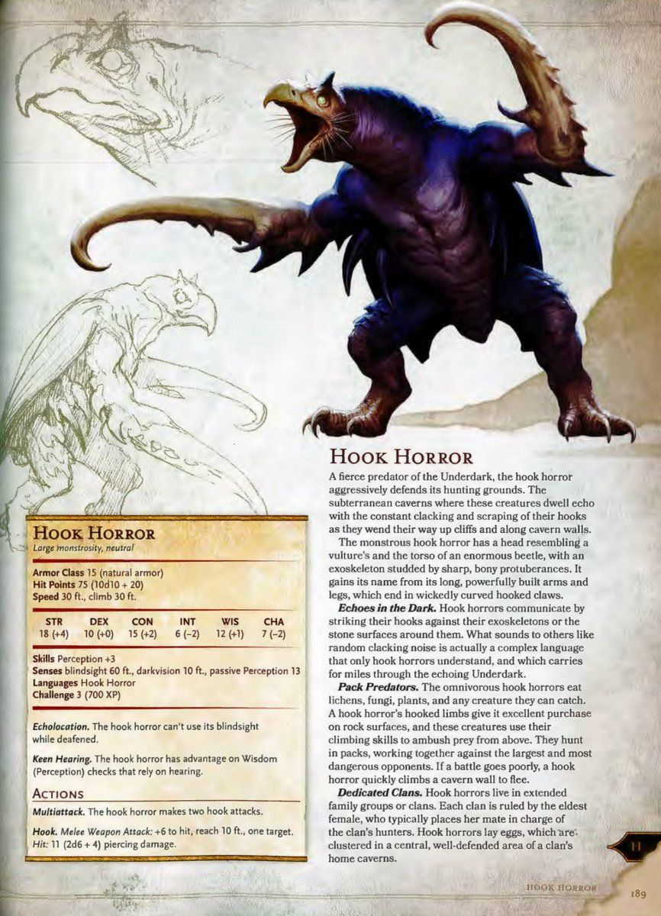
JM: Weapons with basic attributes like “+2 to hit” are a must, I’d like to be able to add additional damage type, for example the Flametongue’s extra 2d6 Fire damage. The damage doesn’t have to be randomized, though. It would also be really nice to have some more complicated weapons like the Sunblade, with its extra damage against Undead, but that’s not necessary if it gets in the way of other functions. It would be sufficient to account for other types of item, like Amulets of Health, within the creature’s statistics, as it won’t be changing mid-battle. Actually, items changing hands isn’t really necessary at all, because in practice it’s unlikely that any creature is going to pick up an item during a fight instead of attacking. With regards to creatures, I’d like to be able to enter data straight from the Monster Manual, like for the Hook Horror. It would be nice to be able to add spell-casters, especially low-level, damage-dealing spells like Magic Missile and Firebolt. It’s not necessary to cover spells at all, but the more are covered the better.
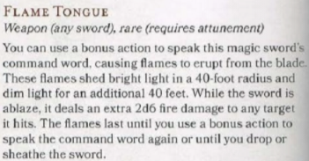
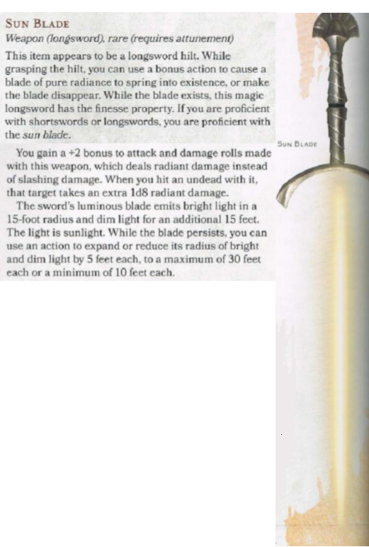
Q: How do you want these to be added?
JM: However is needed to allow maximum freedom of customisation. It’s crucial that I can make homebrew creatures and other things that wouldn’t normally be in an encounter fit into the simulations.
Q: It would be virtually impossible to create a user interface that creates new classes. Would it be acceptable to enter new data directly into the code of the program?
JM: If it provides more customisability in what I can create for the simulations, that would be fine. However, for the purposes of accessibility, it would be preferable to use configuration files to add data instead.

Q: How would you like the user interface to function?
JM: It needs to be turn-based, and it needs to tell me what each manually-controlled creature can do, and present it as a set of options. Presentation isn’t as important, being a GM tool. I also want to know what happens to each creature on each turn.

End User:
Primarily, the end user is game masters and players who want to run and control large-scale battles. However, as it is being created with the goal of being customisable and open-source, the end user is more specifically people like Joe who want to be able to customise and create creatures, put them into a simulation and watch them fight each other

Acceptable limitations:
- Area-of-effect (AoE) attacks will be impractical to run. This is because large-scale battles would require large numbers of creatures being checked for their position when such an effect (eg, a Fireball spell) takes place, which would be likely to cause problems for game performance. This is exacerbated by the issue of displaying such an effect using VB. This means that battles involving spellcasters will be unfeasible.
- As the program is intended as a tool for the GM as opposed to a game, basic graphics are sufficient for the display.
- House rules, such as critical hits, are not practical to add as they vary too much between GMs to be a useful feature.
- Terrain and obstacles are not common enough in combat encounters to be necessary outside of limiting the size of the battlefield.

Existing systems in the area:
Several existing programs have attempted to simulate fights, and many have become popular in recent years. Many such programs also include the ability to take manual control of creatures, even mid-fight, such as TABS (Totally Accurate Battle Simulator) and UEBS (Ultimate Epic Battle Simulator).
TABS mostly focuses on being challenging the player to find ways to counter various combinations of creatures (or “units”), and as such does not include customisability as one of its main goals, nor therein does it include performance on a large scale. However, it does have a connection to the Steam Workshop, where the community can develop custom units and use them in-game. It also includes a Sandbox mode, where the player controls both sides of the battlefield and has no limit to the number of units they can use. This means that both customisability and high performance for large-scale battles remain in the interests of TABS.
UEBS is a more significant competitor for our program, as its main selling point is that it allows the user to set up extremely large-scale (or “epic” as in the title) battles. It also has a system to customise units, although it has no system to customise specific equipment or effects applied to those units, so each unit is still effectively the same but with behavioural differences and different statistics.
The key difference between our program and these two simulators is that TABS and UEBS are both real-time simulators with their own rules, whereas our program is turn-based and bases its rules off 5th Edition Dungeons & Dragons. This means that our program is a bespoke simulator for Joe’s requirements, whereas TABS and UEBS are videogames which are analogous to the environments of classical D&D.

Objectives:

1- Calculate attack range with Pythagoras’ theorem, i.e.: whether the attack range is greater than (x^2 +y^2 +z^2) ^0.5 (Test C3)
2- Display creature positions with the correct coordinates, and update while the PC moves. (Test C3)
3- Provide a framework for adding new Effect subclasses with new functionality in combat which will be implemented without the new effect being required to be mentioned within the rest of the solution. (Test C3)
4- Allow the player to take their actions, movement and bonus action in any order. (Test C3)
5- Enable new items to be designed by the user and implemented automatically, i.e. can be used by creatures without changes to the code. (Test A1)
6- Enable new creatures to be designed by the user and implemented automatically, i.e. can be used in designing scenarios without changes to the code. (Tests A1-A11)
7- Enable the user to design new scenarios, including what creatures are present, what faction they are aligned with and what position they start combat at. (Tests A1-A12)
8- Allow the user to select from configured scenarios and run one. (Test B1)
9- Allow creatures to be manually or automatically controlled, as determined in configuration. (Tests A1, A2 and C3)
10- Provide basic intelligence for creatures under automatic control (Tests C1 and C2)
11- Apply the rules for 5th Edition D&D for attacks:
- Adjust attack rolls based on the attacker’s attack modifier
- Adjust attack rolls based on the attack modifier of the weapon used
(Test C4)
12- Determine whether attacks hit based on the defender’s AC. (Test C4)
13- Apply damage from a successful attack based on:
-weapon type
-weapon bonus
-additional effects from weapon attributes, e.g.: Flametongue
-defender’s resistances/immunities to damage types
(Test C4)
14-Modify number of attacks per action a creature takes based on its characteristics. (Tests A1-A2)
15- Determine that a creature has been defeated if, and only if, its current HP is at or below 0.
(Test C5)
16-Determine when a battle ends based on when only 1 faction is left standing. (Test C5)
17-Report updates from the results of effects and attacks. (Test C1)
18-Display the movement and locations of creatures. (Test C1)
19-Give users the choice of what their controlled creature does on each turn. (Test C3)

Modelling:
Use Cases:
- Adding or modifying scenarios
- Simulating stored scenarios (fully automated)
- Running stored scenarios (with manual controls)

Design
Top-level Overview

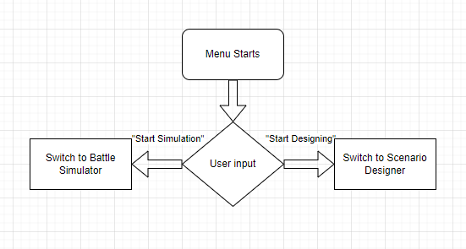
The menu structure of the application is extremely simple, as it only needs to accomplish 2 tasks: designing a scenario, and simulating scenarios.
Data Structures
Binary files will be used to store data for the scenarios. Binary files have been chosen over a database for this as the VB.NET framework contains inbuilt functions for serializing and deserializing objects into Binary files, meaning storing scenarios can be done simply and efficiently, compared to databases which are more complex to access. Despite there being a large amount of data, all the data will be regarding essentially the same thing, meaning no data manipulation will need to be performed on the data stored, such as the CRUD operations for which the database format excels.
Binary files are also used for the public creature definitions which can be created from the Scenario Designer, for the same reasons described above. These are stored as “.cdef” files to distinguish them from the scenario files which are tagged as “.scenario”.
All files used to store user-saved data are stored in the Filestore folder in the project bin.

User Interface Design

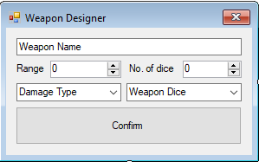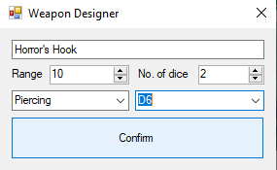
This is the weapon designer. From here, the user can create a custom weapon for their creatures to use, with its own damage numbers, range and damage type. This is accessed as a pop-up window from the Scenario Designer, as it is only needed temporarily while designing a new creature definition.

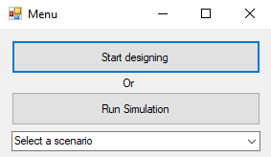
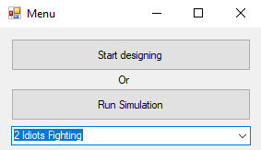
The main menu is designed to be small and simple, so that the user can move quickly between windows without having to navigate through too many selection panels, if they want to test individual or small aspects of a scenario.
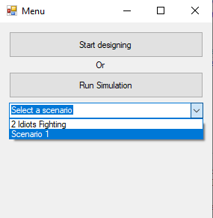
Once one of the “child windows” has been closed, the menu will re-open and update with any new scenarios which have been added since the last time the menu was opened.

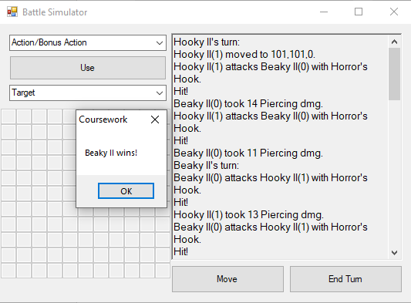
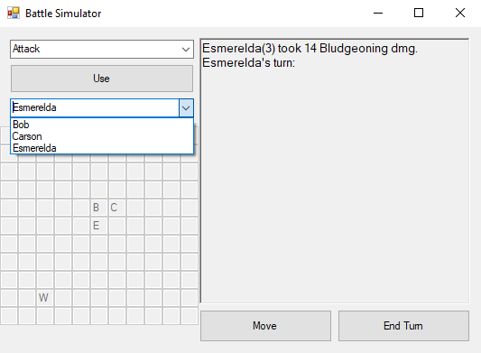
The Battle Simulator is the focus of the program, and as such has the most diverse and interactive user interface of the windows. It includes a combat log (a rich text box containing a set of reports from notable creatures in the scenario about what has happened during combat), as well as a set of controls so that the user can control a PC if one is included in the scenario, including:
-A grid which displays the position of each creature in proximity to the PC, using the first character of their name as identifiers,
-Buttons to tell the PC to move, end their turn or use a “power” – an umbrella term for any class feature or spell that uses some type of action, and
-Combo boxes for the user to determine what “power” the character will use, and on which target within range.
Once the scenario has concluded – only one faction has any creatures remaining, a message box is displayed with the names of the remaining creatures. The user can still interact with the form and the combat log once this message box is closed, but it serves to notify the user that combat is over.
Whether or not a creature should report on something happening inside of combat is determined by the user in the Scenario Designer, via the Do Reporting property.

Design of Core Algorithms
The activity diagrams below describe the existing D&D rules as they will be applied in the program:
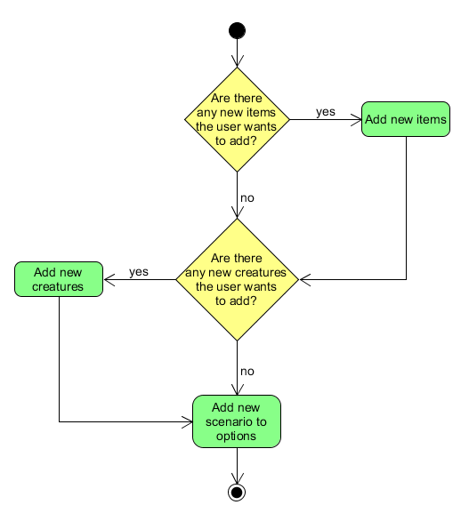
Adding or modifying scenarios:

Run scenario:
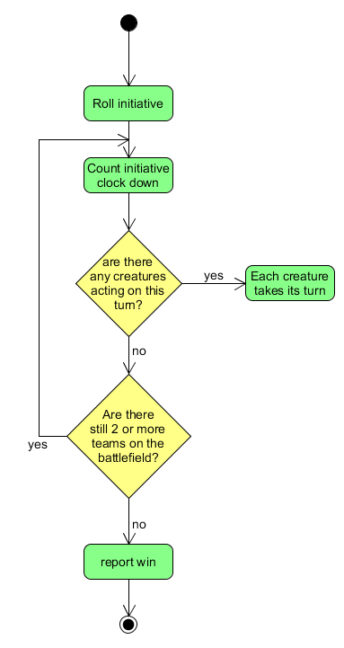

Automatic scenario:
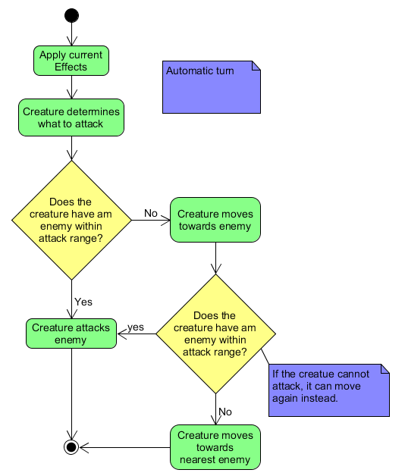

Player controlled scenario:
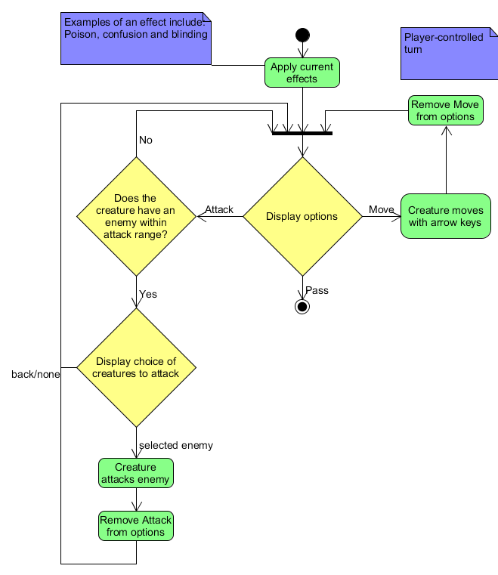

Creature attacks enemy:
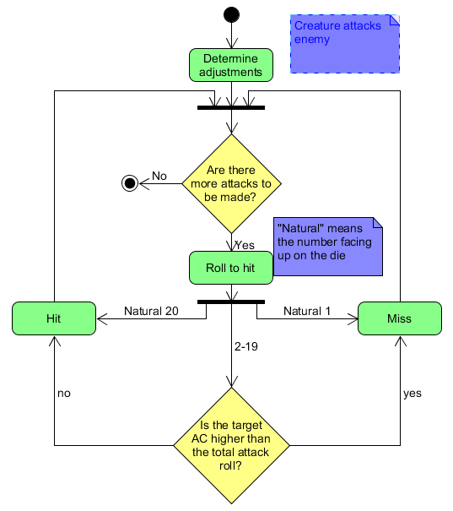

Research Sources for Program Development
https://stackoverflow.com/questions/1490663/whats-the-easiest-way-in-vb-net-to-parse-this-xml-into-objects
https://stackoverflow.com/questions/5949454/can-i-deserialize-an-object-when-the-underlying-class-has-been-changed-slightly
https://docs.microsoft.com/en-us/dotnet/standard/serialization/binaryformatter-security-guide#binaryformatter-security-vulnerabilities

Technical Solution
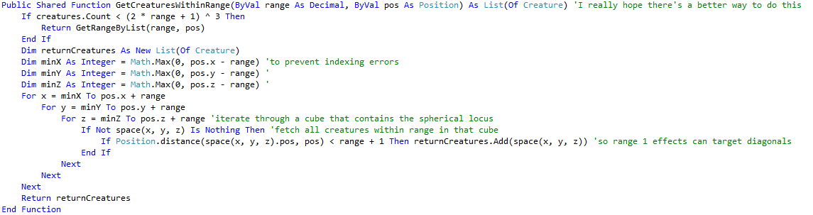
The source code for the technical solution has been attached alongside the main documentation, due to the large quantity of code. The following algorithms are not easily represented as activity diagrams, so I have included the annotated code for the important algorithms represented:

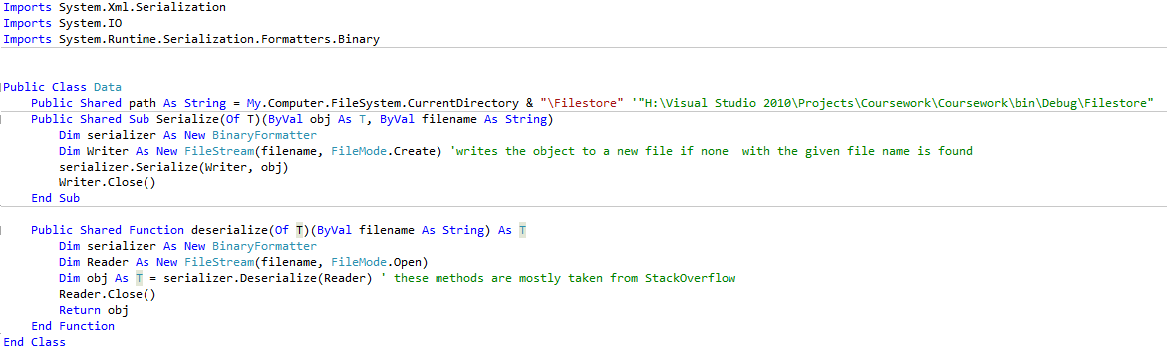
This function creates an imaginary cube around the area to be searched and iterates through each position within that cube. It then filters each creature in the area according to whether they are within the actual (spherical) area to be searched and returns the list of creatures that are.

These functions, responsible for all the file manipulation in the program, are built on VB’s inbuilt BinaryFormatter and FileStream classes, designed to make file manipulation easier for developers. They are lightly modified versions of methods from StackOverflow, as the original versions did not close the file stream after being used. As well as some other minor problems.

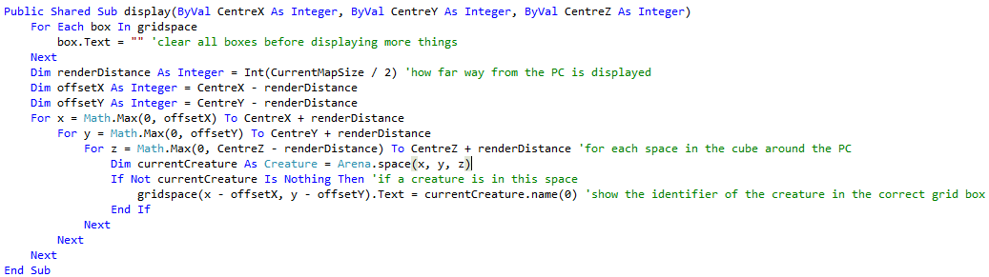
This function updates the display to fit around the PC whose turn is currently under the user’s control.

Testing of the Technical Solution
The following test plans detail the tests required to determine whether the technical solution meets the goals laid out in the Analysis and functions as intended.
Scenario Designer(A)
Test No. | Test Type | Test Purpose | Test Data | Expected Result
1 | Normal | To test that the definition creator can successfully add a creature definition with “normal” characteristics, ie: only actions are those available to all creatures in D&D unless stated otherwise | From the Hook Horror entry in the Monster Manual, shown above (with Brute AI) | The creature definition is added, and the user is told this by a message box
2 | Normal | To test that the definition creator can successfully add a “normal” new public definition (described in Test 1) | Hook Horror as in Test 1 | The creature definition is added as in Test 1
3 | Boundary | To test that all values which can be given for creature definitions can be implemented into a scenario successfully. | Highest values possible for all fields, name: “Test 3” | The creature definition is added as in Test 1
4 | Boundary | To test that all values which can be given for creature definitions can be implemented into a scenario successfully. | Lowest values possible for all fields, name: “Test 4” | The creature definition is added as in Test 1
5 | Erroneous | To test that the Definition Creator can avoid a fatal error when no data is given | No data | Error message displayed to user, and the definition is rejected
6 | Erroneous | To test how the application reacts to erroneous data types | “_” for all numeric fields, Test 1 data for others | Definition rejected as in Test 5
7 | Normal | To test that the creature creator can successfully add a new creature form a “normal” creature definition (as described in Test 1) | Hook Horror definition and Faction 2; default inputs for all other fields | New Hook Horror is added at the default position, with name “Name”
8 | Boundary | To test whether the boundary values from Test 3 can be implemented into a creature object successfully without error | Definition from Test 3, other values are default | New Test 3 creature is added at default position with name “Name”
9 | Boundary | To test whether the boundary values from Test 4 can be implemented into a creature object successfully without error | Definition from Test 4, all other values are default | New Test 4 creature is added at default position with name “Name”
10 | Erroneous | To test whether the Creature Creator can avoid fatal error when no data is given | No data | Creature is rejected and an error message is displayed
11 | Erroneous | To test how the Creature Creator reacts to a non-existent creature definition | Definition: “Test 11”, all other values are default | Creature is rejected as in Test 9
12 | Normal | To test whether the Scenario Creator can successfully save a scenario | All successful definitions and creatures from Tests 1-11 | Scenario is added successfully

Menu (B)
Test No. | Test Type | Test Purpose | Test Data | Expected Result
1 | Normal | To test whether the menu can correctly load a saved scenario | Scenario created from tests above | Scenario loaded successfully
2 | Erroneous | To test how the menu responds to a non-existent scenario | Scenario name: “Test 2” | Scenario rejected and User is told this by a message box

Battle Simulator (C)
Test No. | Test Type | Test Purpose | Test Data | Expected Result
1 | Normal | To test how the Battle Simulator responds to a collection of “normal” creatures | Scenario with 2 Hook Horror creatures on opposing factions | Scenario simulated and concluded successfully, ending with a message box displaying the winner remaining
2 | Erroneous | To test how the Battle Simulator responds to creatures starting in the same position | Scenario created from Designer tests above | No creatures move; otherwise battle works as normal
3 | Normal | Testing Objectives 1-4 from the Analysis | Player-controlled creature with a Flametongue and a Power that uses a bonus action, and a hook horror | PC can move to within range of the other creature, at which point the hook horror becomes displayed as a target. Positions are updated as PC moves. On hit, the Flametongue deals extra Fire damage, and Bonus Action can be taken before or after Action.
4 | Normal +Border | To confirm how attacks and calculations of damage are performed within the simulator (Objectives 11-13) | Scenario from Test 2 | Attacks correctly add the base attack, weapon bonus and natural roll and compare to AC. Damage correctly uses resistance, weapon damage and damage modifiers.
5 | Normal | To confirm how scenarios’ end points are determined (Objectives 15-16) | New scenario with 3 factions, with varying numbers of hook horrors | The faction which wins contains at least 1 creature with positive current HP, and no other factions do, at the end of combat.

Test | Test Data | Test Result | Pass? (Y/N)
A1 | 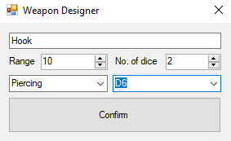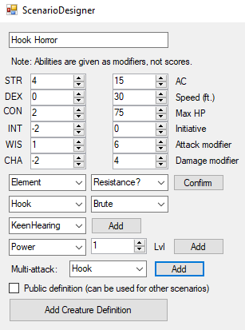  Hook was added twice to the Multiattack and the properties Keen Hearing, Darkvision and Blindsight were added to Properties. | 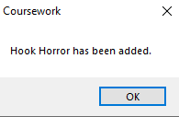  The Hook Horror is now available to use for new creatures in this scenario. | Y
A2 | 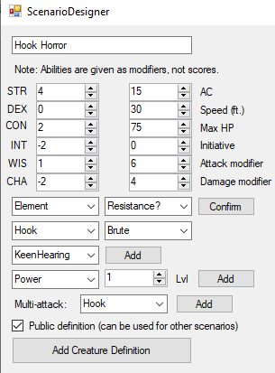  This is the same definition as in Test A1, but it is public now. | 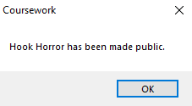    Hook Horror is now available as a public definition. | Y
A3 | 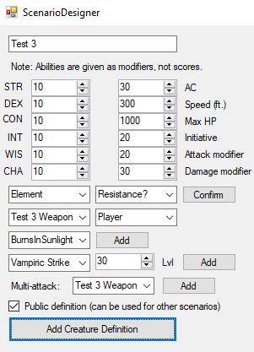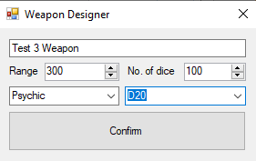 | 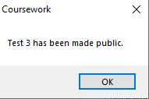  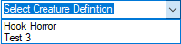 | Y
A4 | 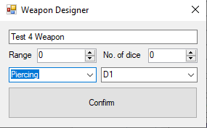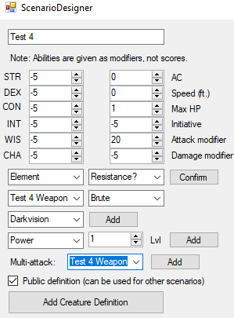 | 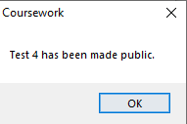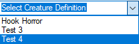 | Y
A5 | 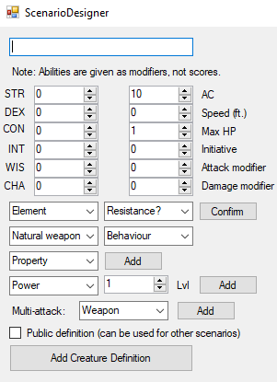  No data has been given, and default name has been removed. | 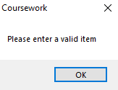  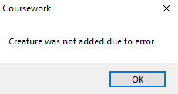  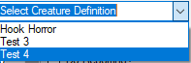  2 errors have been reported, and the definition was not added due to the errors. | Y
A6 | 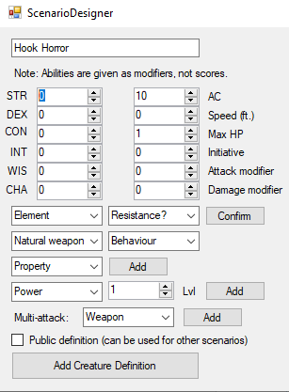Non-numeric values are unable to be entered | Non-numeric values are unable to be entered – data was rejected, but no error message displayed | Invalid test
A7 | 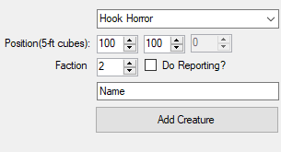 | 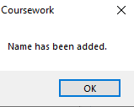 | Y
A8 | 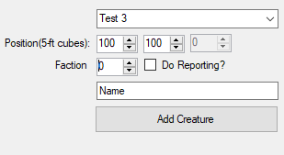 | 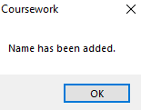 | Y
A9 | 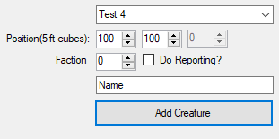 | 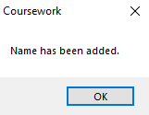 | Y
A10 | 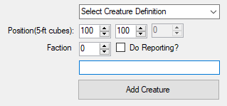 | 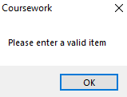  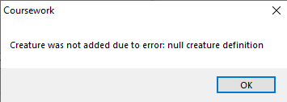 | Y
A11 | 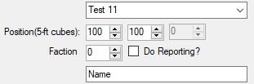 | 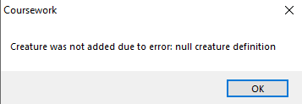 | Y
A12 | 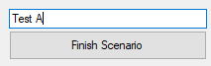Data from previous tests has been stored where successful | Scenario added successfully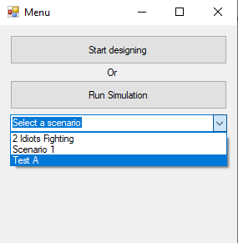 | Y
B1 | 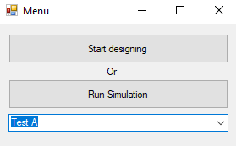 | Scenario loaded successfully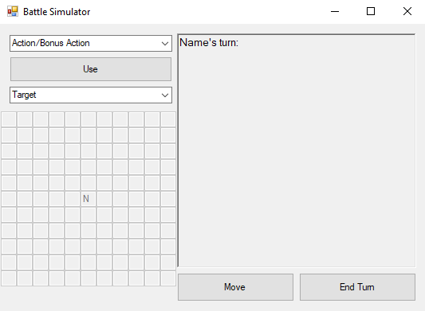
B2 | 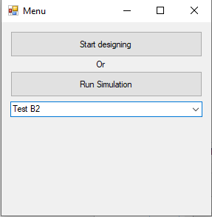  “Test B2” is not an existing scenario. | 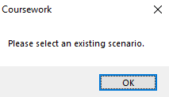 | Y
C1 | New scenario with 2 Hook Horror creatures on opposing factions | 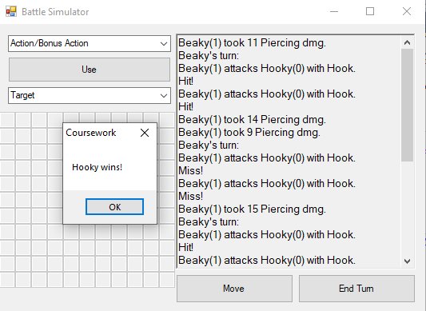 | Y
C2 | Creatures can no longer start in the same position | 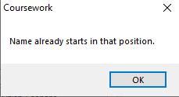 | Invalid
C3 | Player-controlled creature with a Flametongue and a Power that uses a bonus action (“Esmerelda”), and a hook horror | 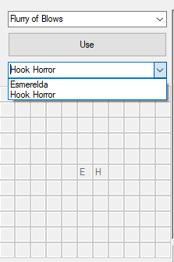 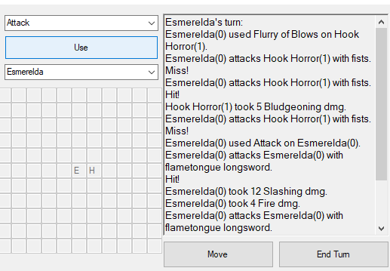 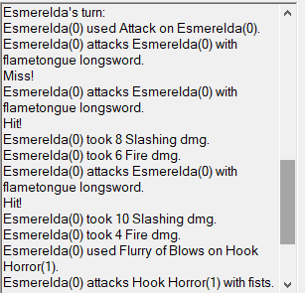As demonstrated, bonus action can be used before or after action, the hook horror is displayed as a target once within range, and the Flametongue deals extra Fire damage on a hit. | Y
C4 | 2 Dragonborns (with 50% resistance to fire damage) and a Fire Breath attack in addition to Longsword attacks  Debug mode: in this test, extra information is given in the combat log which is not usually there. | 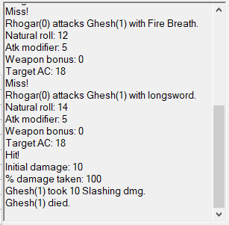 | Y
C5 | New scenario: 1 faction with 3 hook horrors, 1 faction with 2, and 1 side with 1.  Debug mode: in this test, extra information is given in the combat log which is not usually there. | 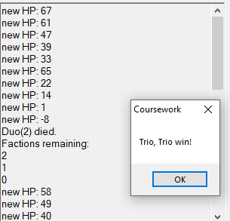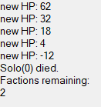  As demonstrated, the scenario only ends when 1 faction remains, and creatures are only reported to have died once their current HP drops to 0 or below. | Y

Evaluation
Review of Specification
The technical solution meets all 19 objectives laid out in the specification, but to different extents. For example, Objective 3 has been met in that effects are a functional aspect of the program which support custom subroutines being made to run (on being applied, each turn etc.) through polymorphism. However, there is currently no support in the application for allowing the user to create their own subroutines in this way, as this would require allowing the user to directly affect the program itself (as opposed to the files used by it.) This may be possible by making use of text documents, but it would require the user to be proficient with the .NET framework and a way to direct the user to the relevant text document.

What could be done with more time?
There are still some limitations of the user interface which could be fixed with more time. These include:
-Adding a feature to allow the user to edit scenarios which have already been saved.
-Adding a weapon designer independent from the scenario designer, with its own public save file as has been implemented for creature definitions.
-Fixing some display issues with the Definition Designer after a custom weapon has been added, such as the most recent custom weapon replacing others that have been made in the Natural Weapons combo box.
The model could also be expanded to accommodate for more complex parts of 5th Edition D&D, such as the Dominate Person spell or effects that end on a successful saving throw, or number thereof, such as Flesh to Stone (see appendix on next page.)

Conclusion
Most of the goals set out by the end user, including all the “must-haves”, have been achieved by the system. However, there are still some “nice-to-haves” which either could not feasibly be achieved or would require more time to do so.
